



Educational Organization Using ServiceNow

**Project Title**

**Team ID - NM2025TMI19497**

**Team Leader - NANDHA KUMAR M K**

**Team Member 1 - JAGAN B**

**Team Member 2 - THIRUNAVUKARASU G**

**Team Member 3 - MANNU KUMAR L**

**problem statement**

Managing admissions, student progress, and administrative work in educational institutions is often done manually or through disconnected systems

objectives

*Automate admission and student progress process.

*Store all records in one centralized system.

*Reduce manual errors using validations.

*Provide real-time tracking for students and staff.

*Speed up admission and result processing.

*Handle large number of student records easily.

*Keep forms and workflows user-friendly.

skills

*ServiceNow Instance setup & configuration.

*Table creation and field design.

*Form layout & UI design.

*Number maintenance (Auto ID generation).

*Workflow creation for process automation.

*Client scripts for validation & calculations.

*Update set creation and migration.

*Testing & troubleshooting in Service Portal.

Step1: Setting Up ServiceNow Instance

* Go to the ServiceNow Developer Site. (https://developer.servicenow.com/)
* Sign In to the Developer Account.

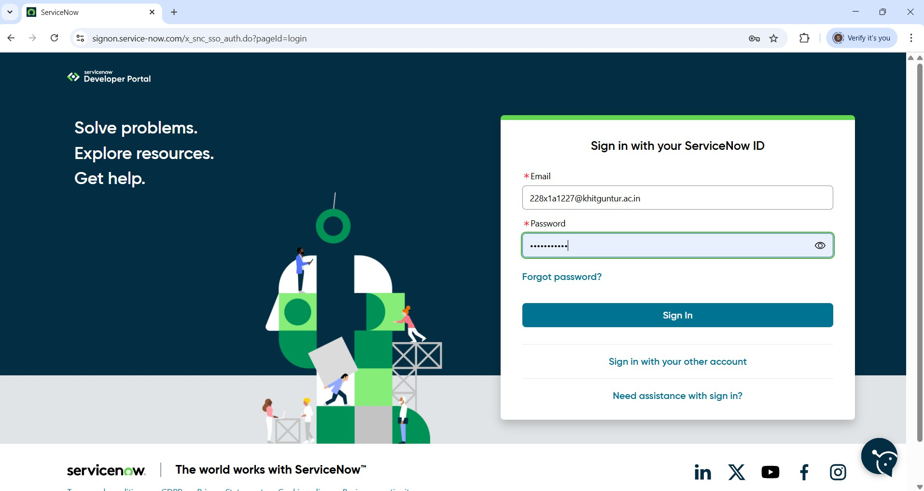

* Request a Personal Developer Instance (PDI)
  + Click on the profile icon at the top-right corner.
  + Select “Manage Instance” or go directly to the link.
  + Click “Request Instance”.
  + Choose the latest version (default selection is recommended).
* Access your Instance
  + You’ll get an instance URL (https://dev225052.service-now.com)
  + Click “Open Instance” to launch it.
  + Your admin credentials (username & password) will be shown-copy and save them securely.
  + Log in to Your Instance.

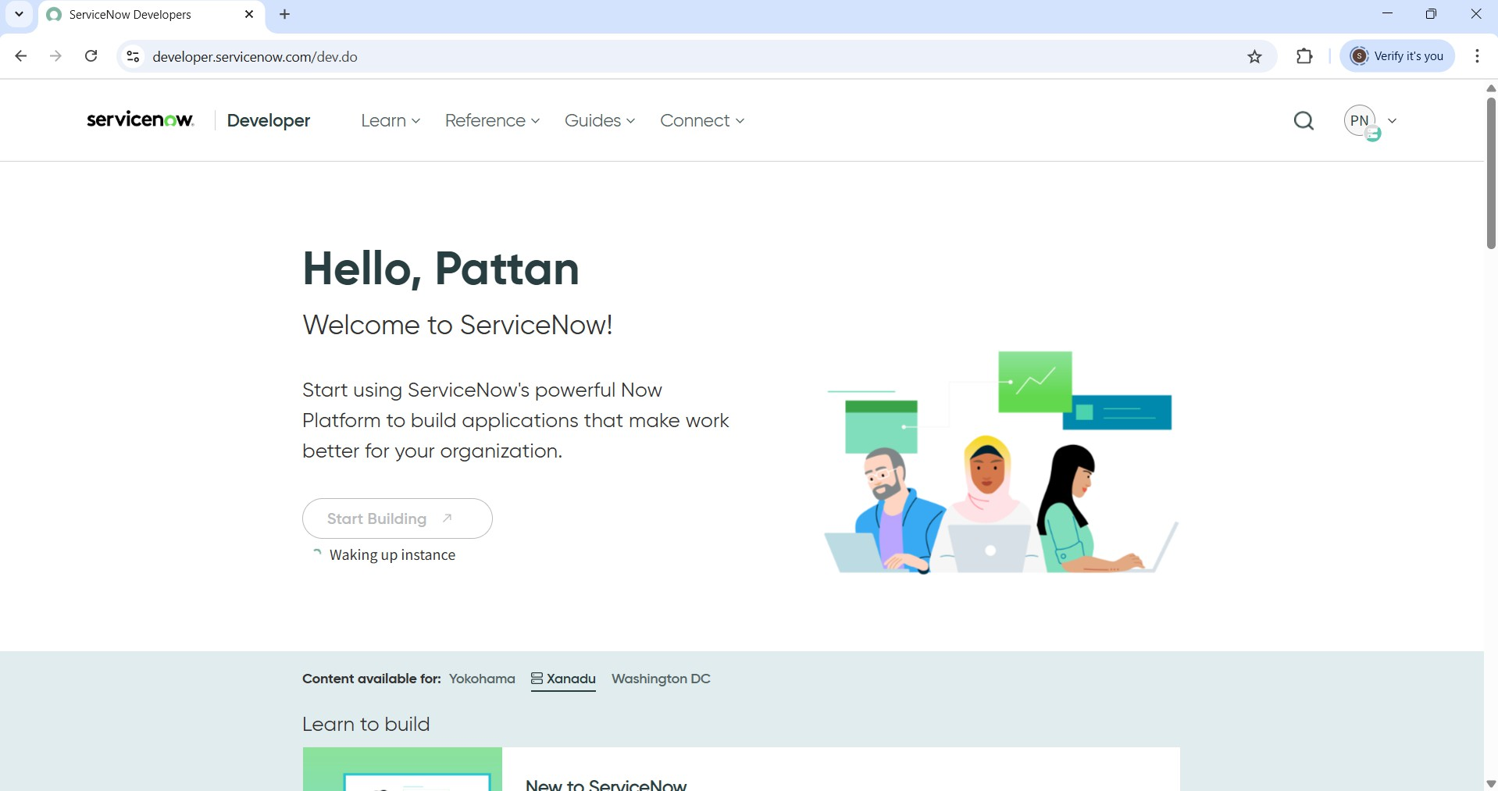

Usage:

* Use the Application Navigator (left sidebar) to explore modules like:
  + Incident, Problem, Change Management.
  + Service CatLog.
  + Configuration Management (CMDB).
  + Workflow Editor / Flow Designer.
* Use App Engine Studio or ServiceNow Studio to build or customize apps.

Step 2: Creation of New Update Set

Before starting the actual development of the project, it is essential to create an **Update Set** in ServiceNow. The update set acts like a **container** or **workspace** that automatically tracks every change or customization made in the platform.

This includes:

* Creating new tables
* Designing forms
* Adding workflows or scripts
* Changing UI elements
* Setting access rules

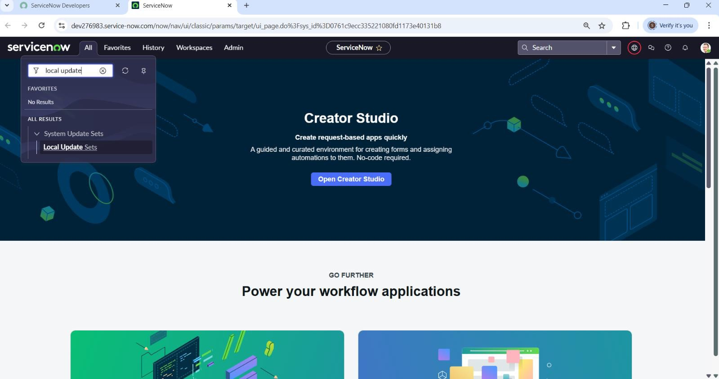

Enter the Details as

Name: Educational Organisation.

Then click on Submit and Make current. From this point forward, all the customizations related to the project were automatically recorded under this update set. This ensured a clean and controlled development environment.

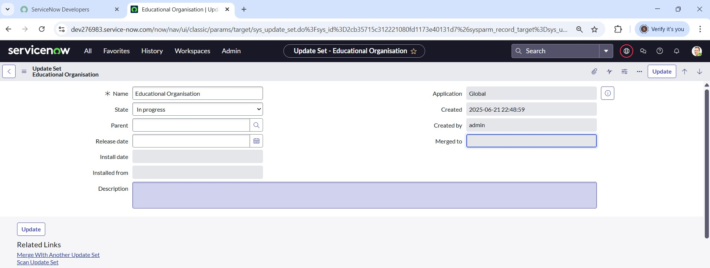

Step 3: Creation of Table

After designing the update set, the next major milestone was to begin building the **database tables** for the Educational Organization system.

1. Creation of Salesforce Table

The first table created was called **Salesforce**, which stores basic student and admission-related information such as: Admission Date, Admin Number, Grade and Student Name etc. This table acts as the **foundation** for storing structured student records.

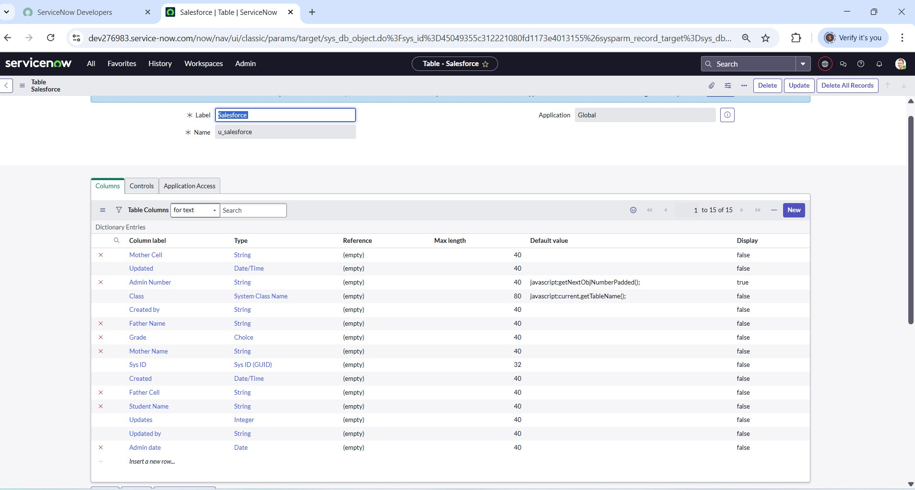

1. Creating Admission Table:

The **Admission Table** was created to manage and track the details of student admissions. It extends from the **Salesforce table**, meaning it inherits all basic student fields while allowing admission- specific additions.

Steps Followed to Create the Admission Table

* + Table Setup
    - Table Name: Admission
    - Extended from: Salesforce (inherits student details like name, contact)
    - Added to Application Menu: Salesforce
    - Made available as a separate module in the left navigation pane
  + Column Configuration
    - Admission Date
    - Grade
    - Purpose of Join
    - Father’s & Mother’s Contact
    - Admission Status
    - School and School Area
    - Fee, Pincode, and Comments
  + ChoiceFields

For several fields, choice lists were configured to maintain consistency and improve user experience. These included:

|  |  |
| --- | --- |
| **Field** | **Choices Configured** |
| Pincode | 509358,500079,500081 |
| Purpose of Join | Tuition, Coaching, Teacher |
| School | Stanley, Naresh It |
| School Area | Near Market, Near Bus stand |

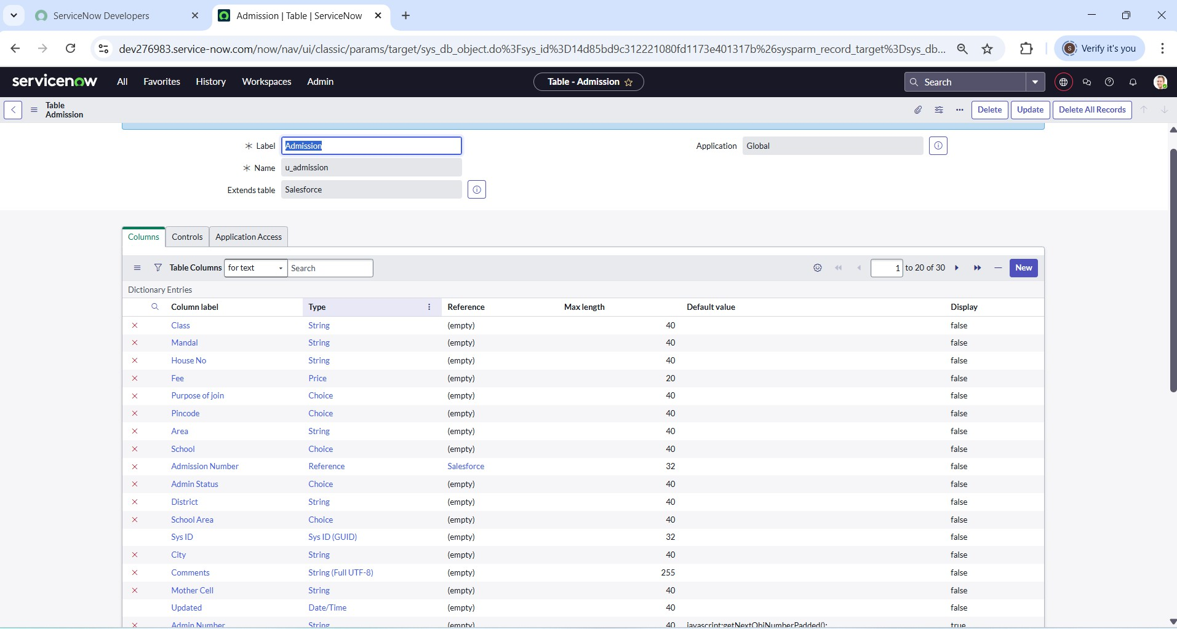

1. Creating Student Progress Table

The Student Progress Table is designed to store the academic performance details of each student. This table plays a vital role in tracking individual subject marks, calculating totals, and deriving overall results such as percentage and pass/fail status.

Table Setup

* + Table Name: Student Progress
  + Added as a separate module under the **Salesforce** application menu
  + Independent table created without extension (as it holds specific performance data

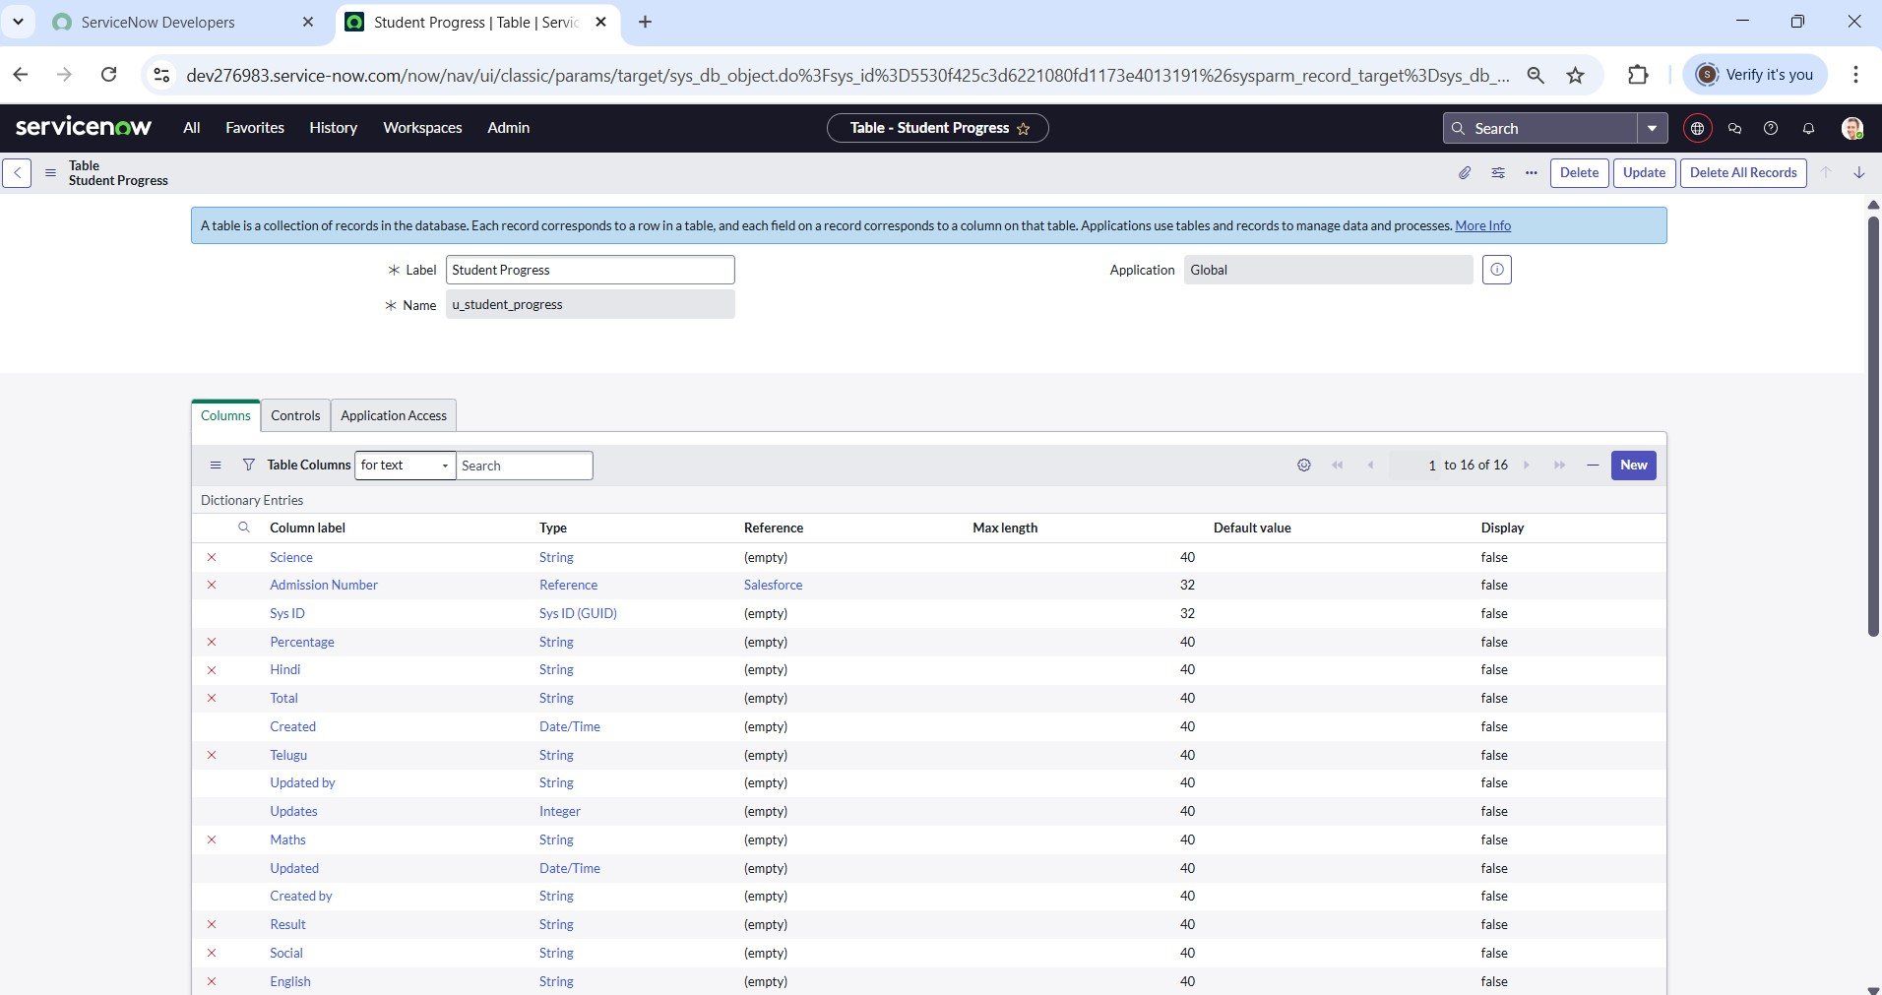

Step4: Form Layout & Form Design

Configuring Form Layout for Student Progress Table

After creating the Student Progress Table, we set up the form layout to make sure all important fields appear in the right order when viewing or editing student records.

Here we select the fields from reference field admission table then the fields formed like:

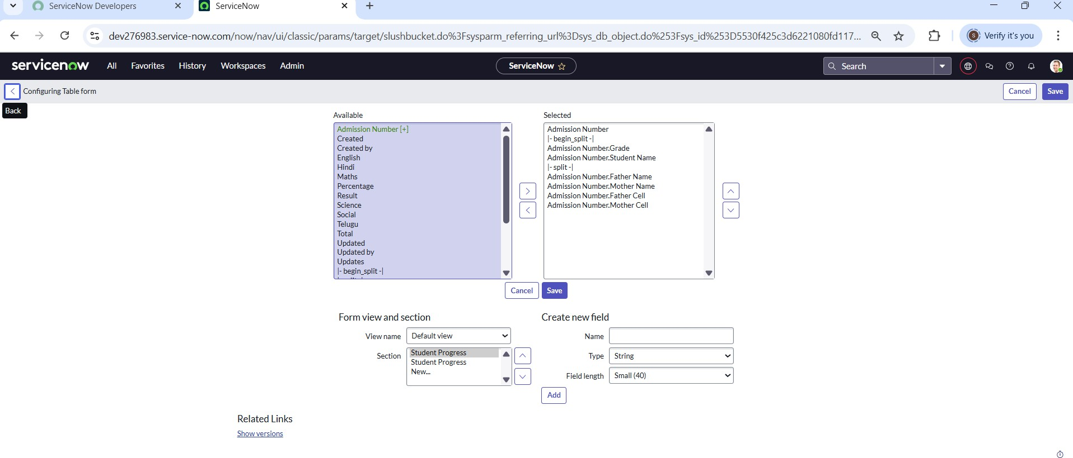

**Creating Form Design for Admission Table**: To make the form easy to use and display all necessary fields properly, we designed the form layout for the Admission Table using the Form Designer**.**

Steps to Design the Form:

1. Go to **Form Designer**.
2. Choose the table (e.g., Admission or student data) from the list.
3. Select The table Salesforce(u_salesforce)
4. From the **Fields** panel on the left, drag and drop the required fields into the layout area:
   * Admission Number
   * Grade
   * Student Name
   * Father Name
   * Mother Name
   * Father Contact
   * Mother Contact
5. Organize them in two columns for better structure (as shown in image).
6. After placing all fields, click **Save**.

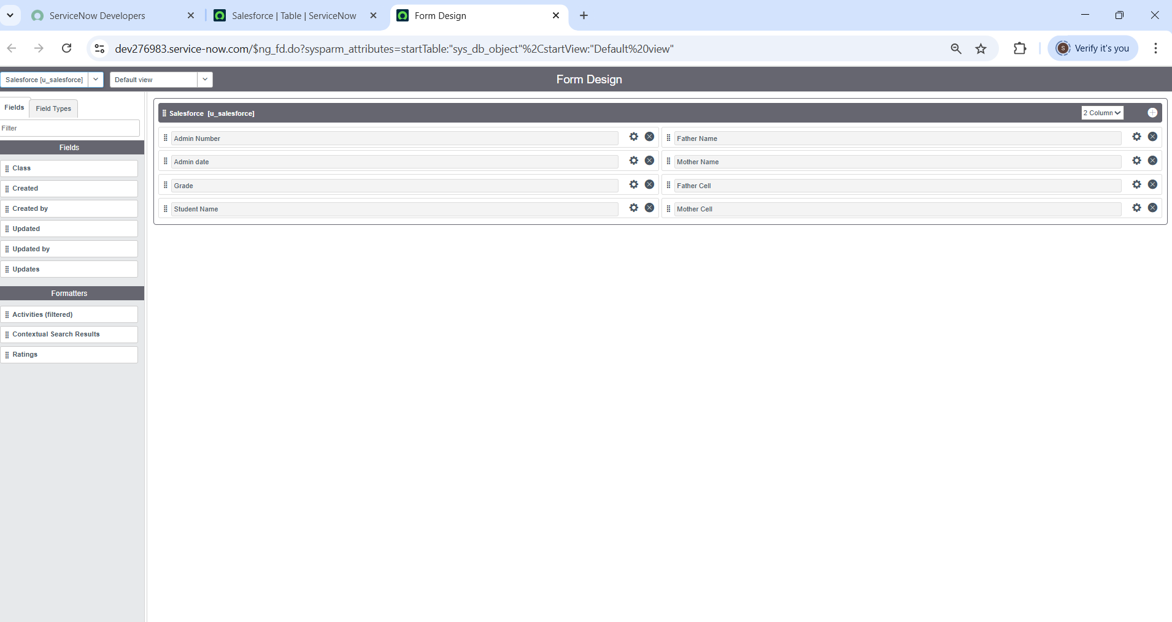

Like this we have design the form for Admission table and Student Progress table as shown in image

Step5: Creating Number Maintenance for Admin Number

Number Maintenance is used to automatically generate unique numbers (like Admission IDs) in ServiceNow. Steps to Create Number Maintenance for Admin Number:

1. Go to Number Maintenance module.
2. Click New to create a new number record.
3. Enter the following:
   * Name: Salesforce
   * Prefix: SAL
4. Click Submit to save the record.

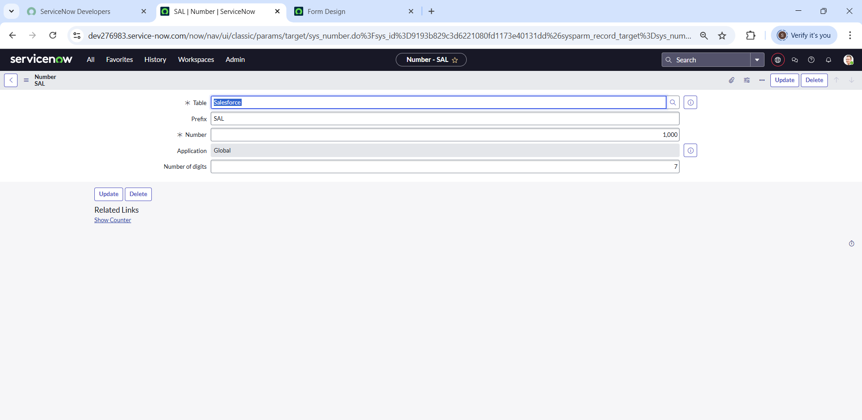

Step 6: Process Flow

Creating Process Flow for Admission Table

Steps:

1. Go to: All → Process Flow → New
2. Fill in the required details (like Table name = Admission).
3. Right-click on the toggle bar and click Save.
4. After saving, change the Name and Label for each stage.
5. Use Insert and Stay to add each flow status one by one.
6. Status Names in Order: New InProgress Joined Rejected Rejoined Closed Cancelled.

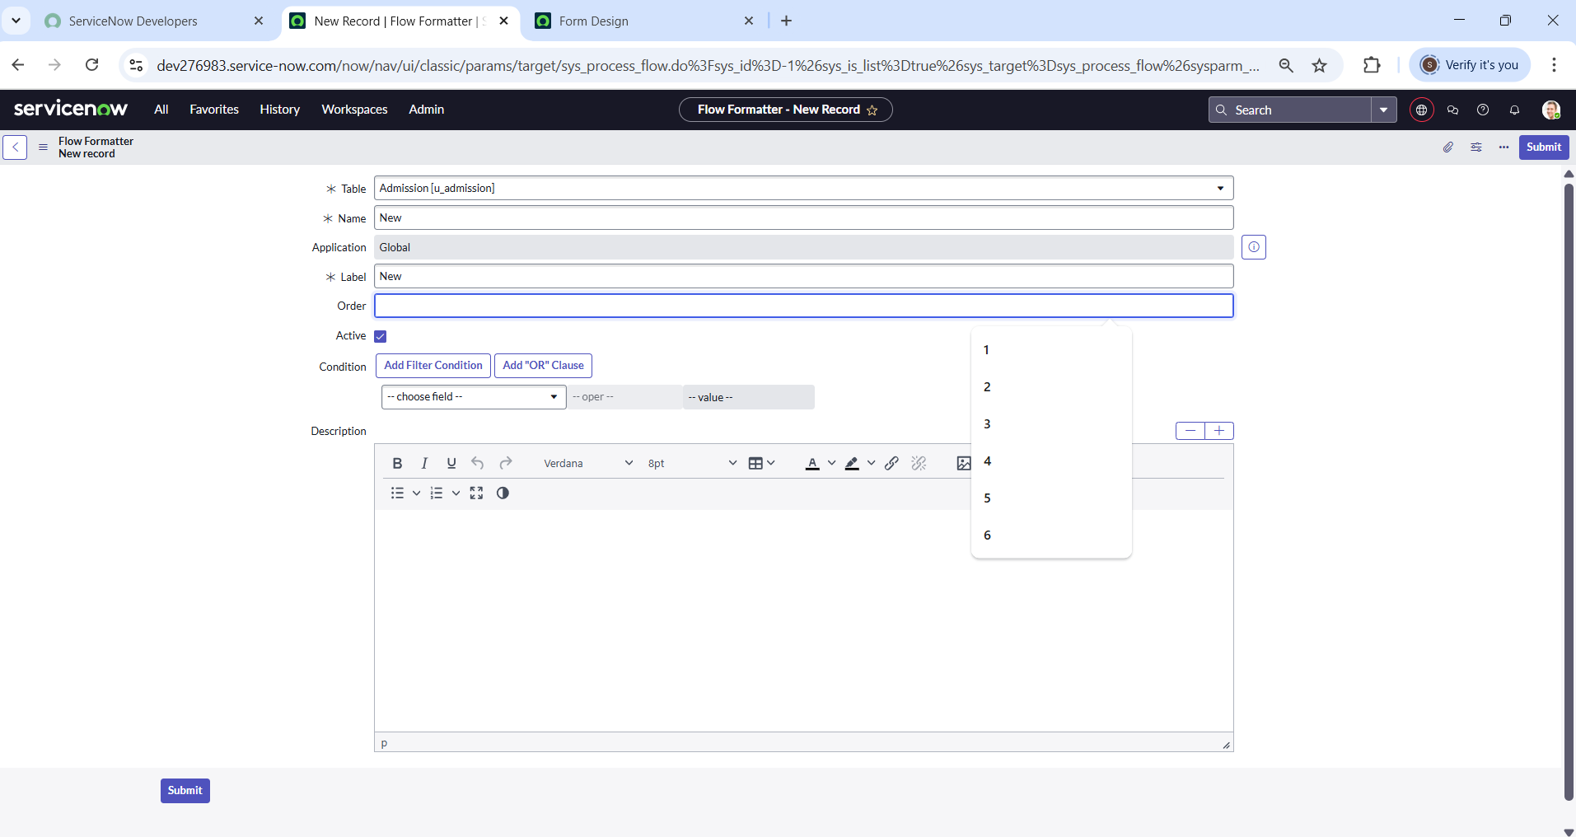

1. Like this we have to create flow for remaining 6 And order should be in above mentioned order.

Step7: Client Script

Auto-Populate Client Script – Admission Table

This script is used to automatically fill in student details on the admission form based on the selected admission number. Steps to Create the Script:

1. Go to: All → Client Scripts → New
2. Fill in the form:
   * Table: Admission
   * UI Type: Mobile/service Portal
   * Type: onChange
   * Field Name: Admin Number
3. Check Isolate Script
4. And write the code

Below image is about the Auto Populate Script

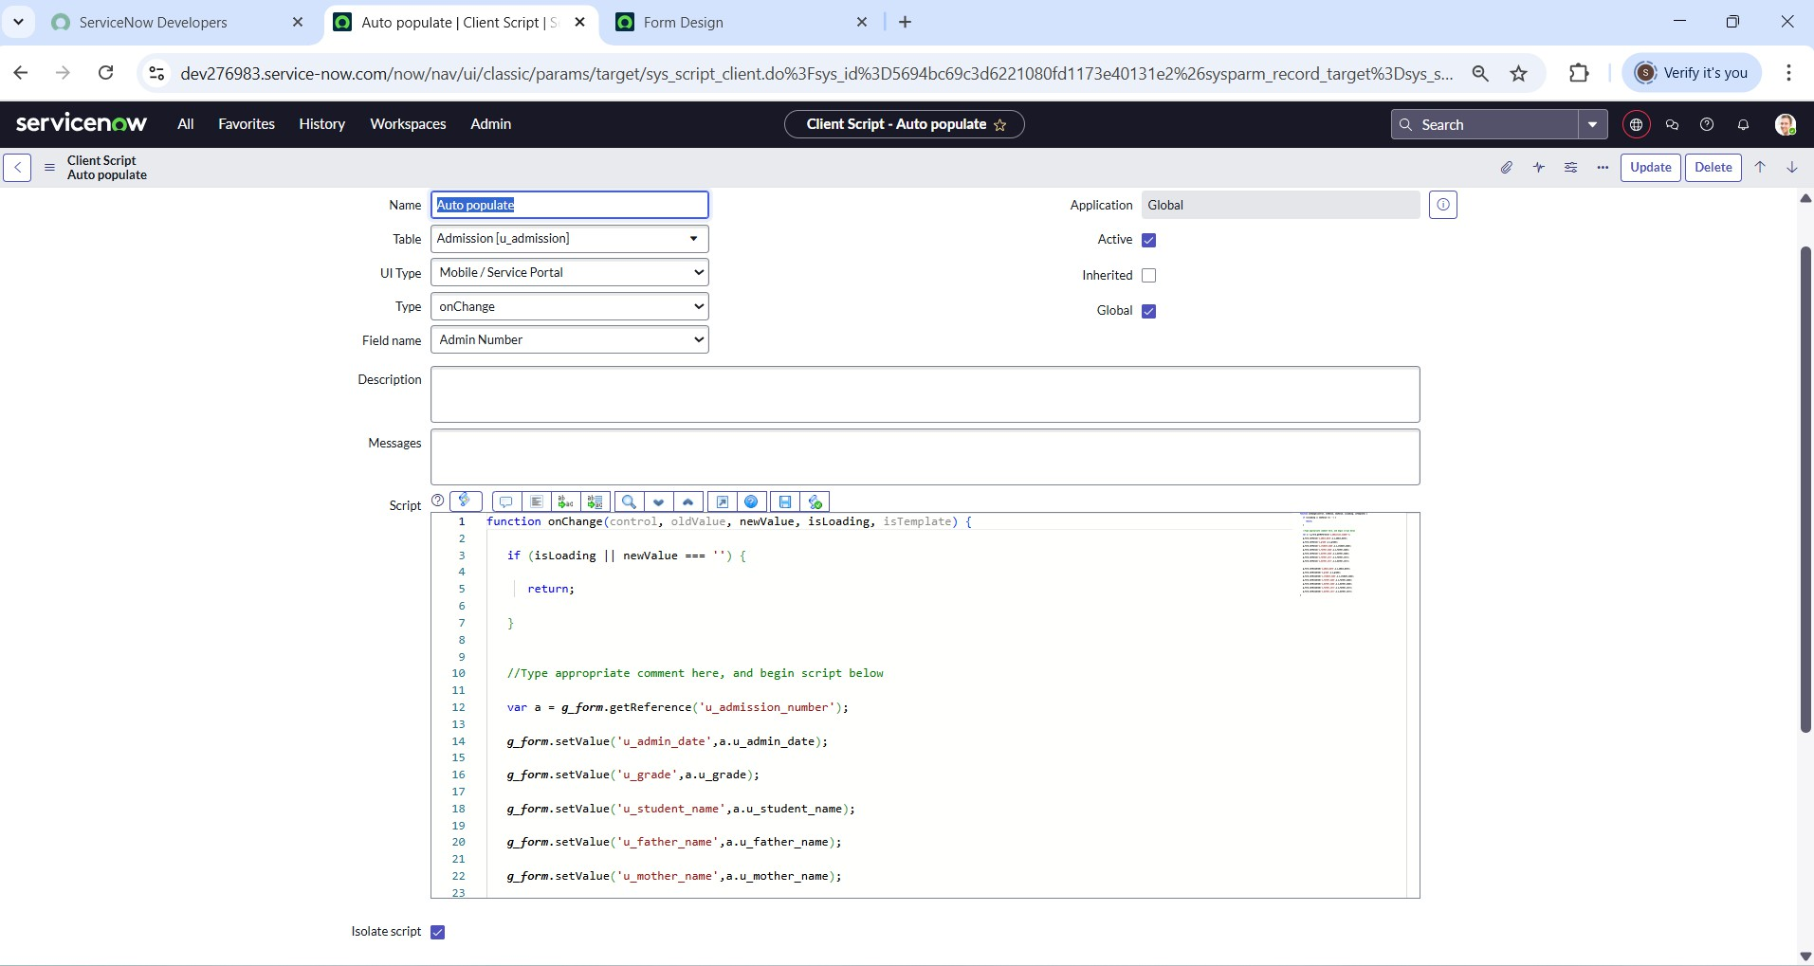

Like this we have to create client script for pincode, disable fields, total update, result ,percentage.

Step8: Result:

* **Admission Table**

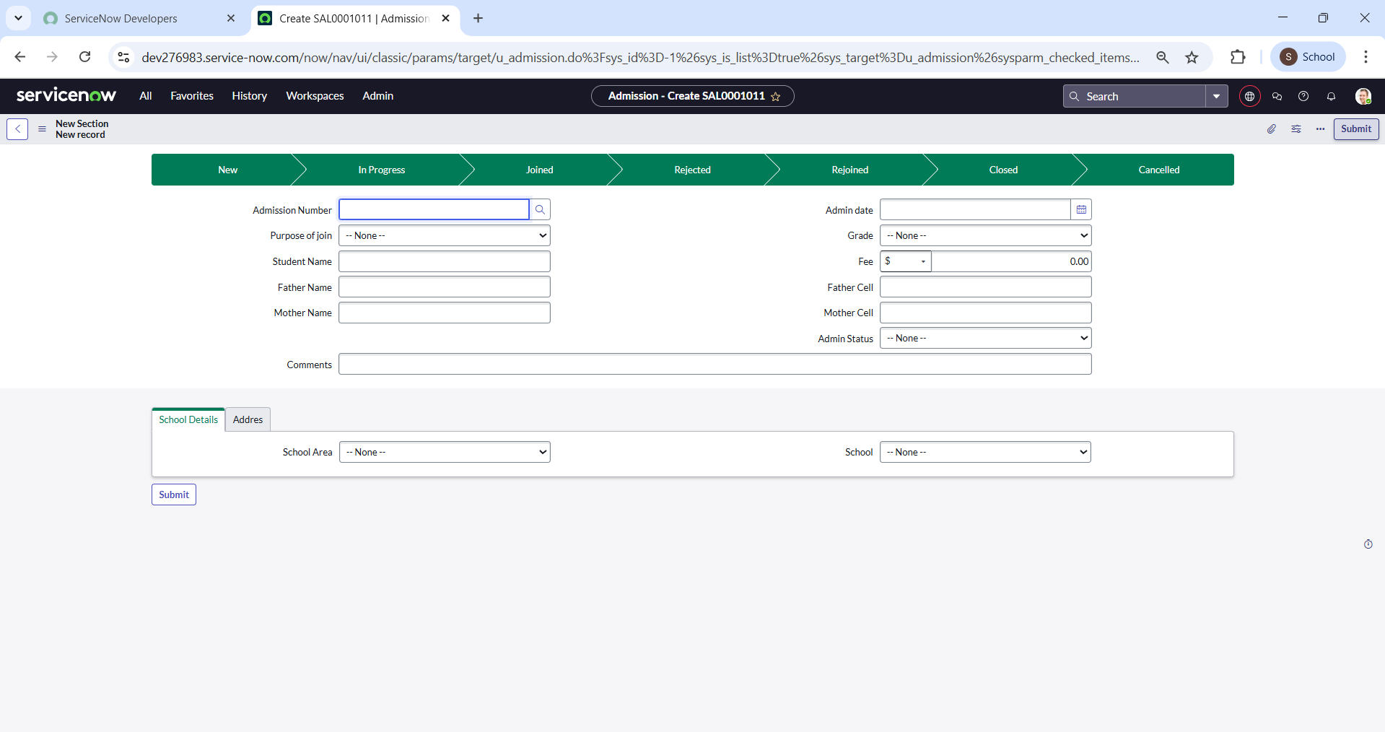

* **Salesforce Table**

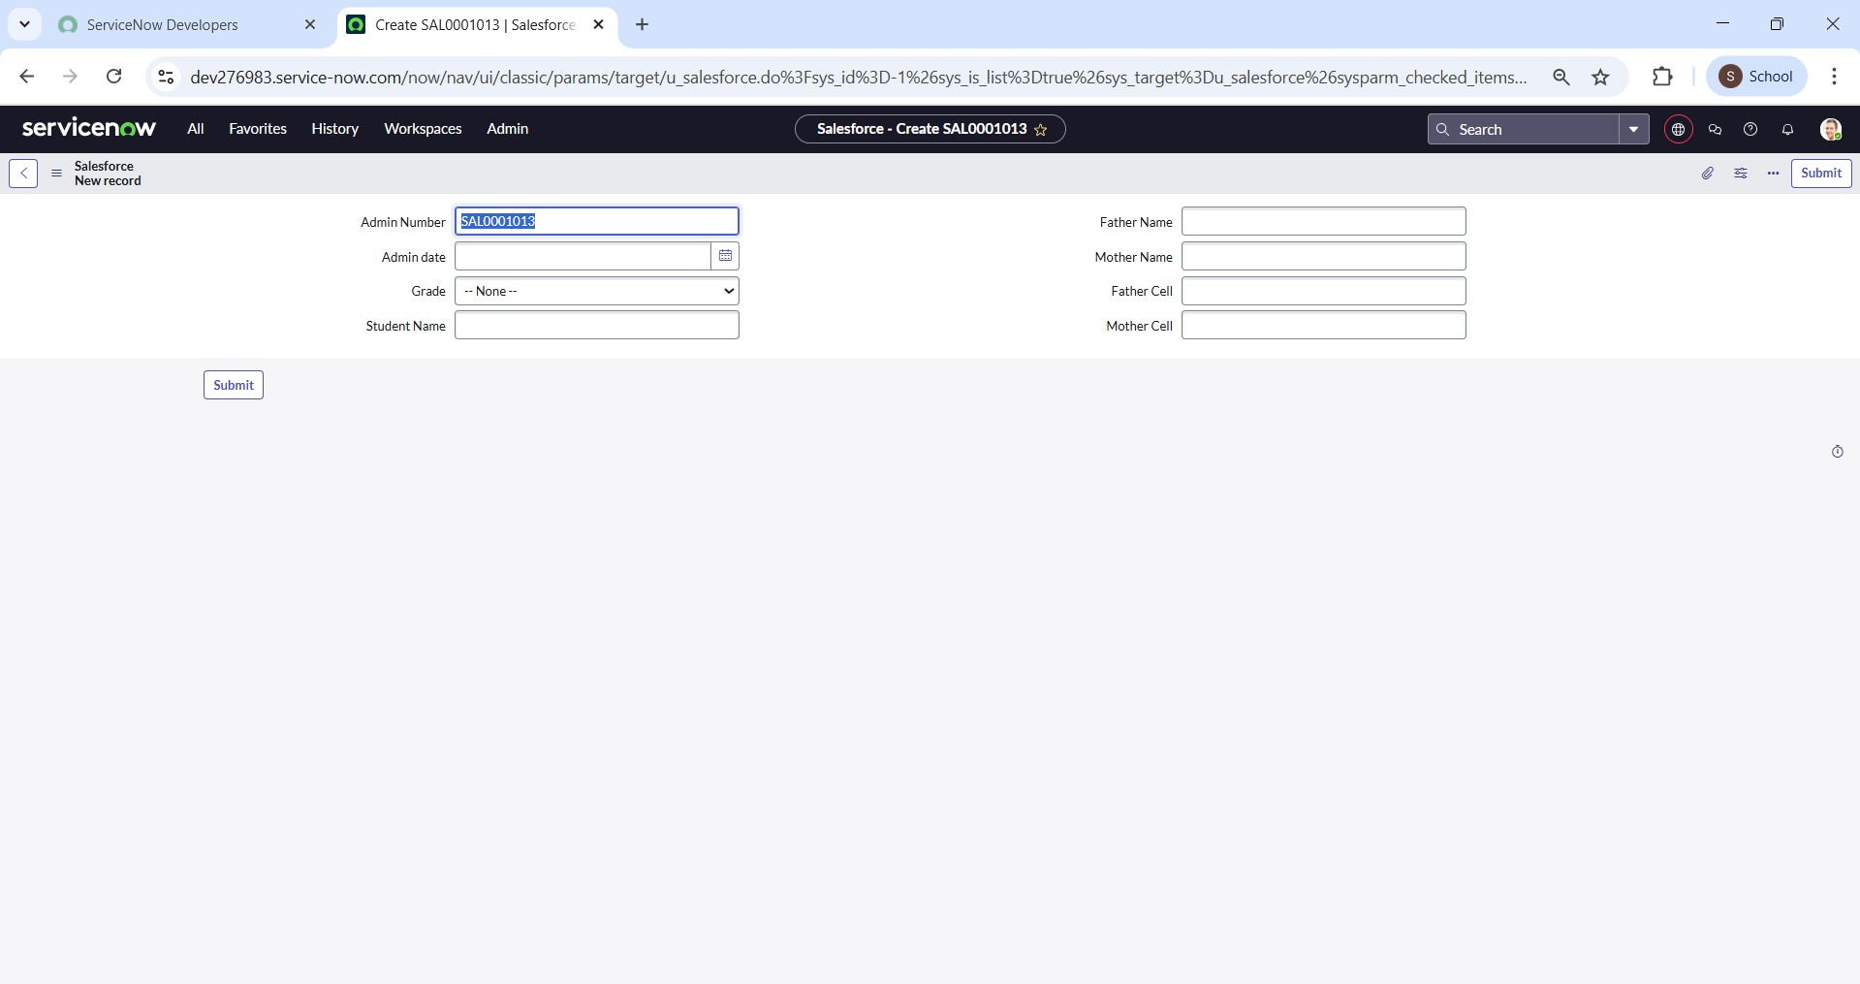

* **Student Progress Table**

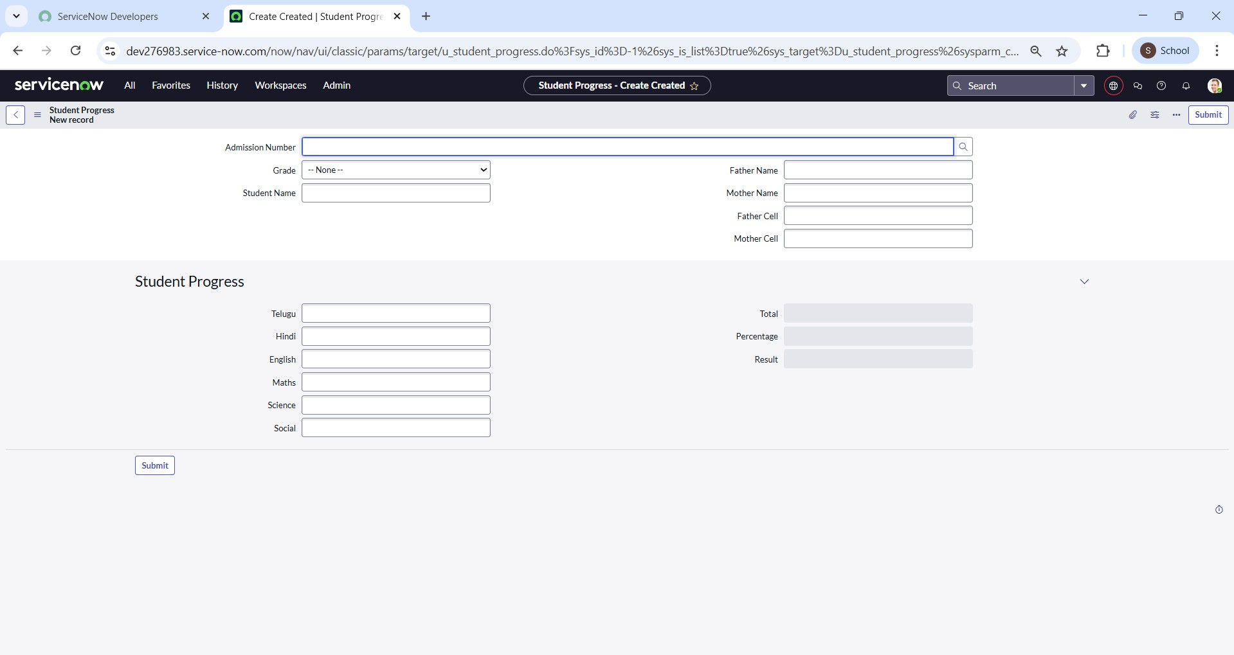 Conclusion:

ServiceNow empowers educational organizations to improve efficiency, streamline workflows, and deliver better support to students and staff. By automating processes and centralizing services, it helps institutions adapt to changing needs and focus more on their core mission—education. Adopting ServiceNow is a smart step toward a more responsive and modern learning environment.